**P235/2**

**ISLAMIC RELIGIOUS**

**EDUCATION**

**(Hadith and fiqh)**

Paper 2

Jul/Aug 2019

2 ½ Hours

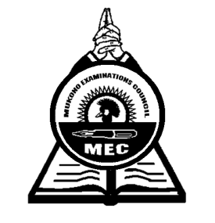

**MUKONO EXAMINATION COUNCIL**

**Uganda Advanced Certificate of Education**

**ISLAMIC RELIGIOUS EDUCATION**

**(Hadith and fiqh)**

Paper 2

2 Hours 30 Minutes

**INSTRUCTIONS TO CANDIDATES**

*The paper is divided into two sections* ***A*** *and* ***B****.*

*Answer* ***any 4*** *questions taking at least one from each section.*

*All questions carry equal marks.*

*Any additional questions will not be marked.*

**SECTION A**

*Hadith*

1. Explain the contribution of the following early ................................... to collection of Hadith.

a) Ibu Shibab Al- Zuhu

b) Mach bin Anaj

1. Examine the contribution of Iman Muslim to hadith compilation.
2. Examine the contribution of Al-Trimdlu to the development of Hadith.
3. Explain the various methods of Hadith scholars to detect forged Hadith.
4. Explain the circumstances under which Hadith is classified as Hassan.
5. Analyse th nature of Hadith .........................

**SECTION B**

1. Discuss the relationship between the Qur’an and the source of Islamic war.
2. What qualifies Ijma as a source of law?
3. Give the characteristics of;

a) Makmh acts

b) Haram deeds

1. Assess the contribution of Imam Ahmed bin Harbarl to the development of Islamic war.
2. a) Explain the Islamic teachings on the abuse of the property of orphans.

b) How relevant are the teachings to the Muslim country?

1. Account for the opposition of Sharia by the Labourless Muslims.

* ***End -***